**Entity Relationship model**

**1. What do you mean by Entity- Relationship Diagram? Explain**

→ An entity–relationship model (ER model) is a graphical representation of [data model](https://en.wikipedia.org/wiki/Data_modeling) for describing the data or information aspects of a business domain or its process requirements, in an abstract way. The entity-relationship (E-R) data model was developed to facilitate database design by allowing specification of an enterprise schema that represents the overall logical structure of a database.

The E-R model is very useful in mapping the meanings and interactions of real-world enterprises onto a conceptual schema. Because of this usefulness, many database-design tools draw on concepts from the E-R model. The E-R data model employs three basic concepts: entity sets, relationship sets, and attributes, which we study first. The E-R model also has an associated diagrammatic representation, the E-R diagram.

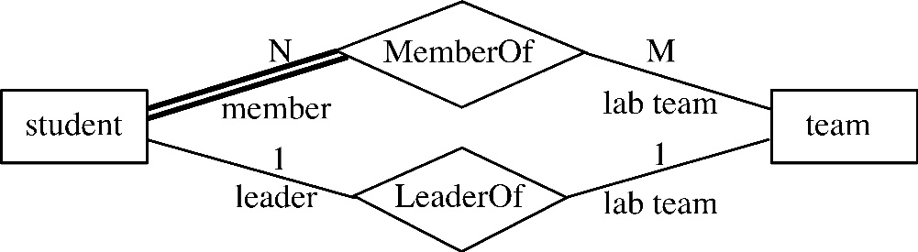

Fig: E-R model Diagram.

**2. Define entity and give an example.**

An **entity** is a “thing” or “object” in the real world that is distinguishable from all other objects. For example, each person in a university is an entity. An entity has a set of properties, and the values for some set of properties may uniquely identify an entity. For instance, a person may have a person id property whose value uniquely identifies that person. Thus, the value 013BSCCSIT034 for person id would uniquely identify one particular person in the university.

Similarly, courses can be thought of as entities, and course id uniquely identifies a course entity in the university. An entity may be concrete, such as a person or a book, or it may be abstract, such as a course, a course offering, or a flight reservation.

**3. Explain the difference between an entity class and an entity instance.**

An entity class is a group of entities of the same type, i.e. VEHICLE. An entity instance is a particular entity, i.e. VEHICLE 12345.

**4. Define attribute and its types.**

Attributes are descriptive properties possessed by each member of an entity set. The designation of an attribute for an entity set expresses that the database stores similar information concerning each entity in the entity set; however, each entity may have its own value for each attribute. An entity is represented by a set of attributes. Possible attributes of the employee entity set are ID, name, dept name, and salary. Each entity has a value for each of its attributes.

* Simple and Composite Attributes

A simple or an atomic attribute, such as City or State, cannot be further divided into smaller components. A composite attribute, however, can be divided into smaller subparts in which each subpart represents an independent attribute. Name and Address are the only composite attributes. All other attributes, even those that are subcategories of Name and Address, are simple attributes.

* Single-Valued and Multi-Valued Attributes

Most attributes have a single value for an entity instance; such attributes are called single-valued attributes. A multi-valued attribute, on the other hand, may have more than one value for an entity instance. One multi-valued attribute can be taken as Languages, which stores the names of the languages that a student speaks. Since a student may speak several languages, it is a multi-valued attribute. For example, a student has only one date of birth and one student identification number. In the E-R diagram, we denote a multi-valued attribute with a double-lined ellipse. Note that in a multi-valued attribute, we always use a double-lined ellipse, regardless of the number of values.

* Stored and Derived Attributes

The value of a derived attribute can be determined by analyzing other attributes. For example, in Figure 2 Age is a derived attribute because its value can be derived from the current date and the attribute DateofBirth. An attribute whose value cannot be derived from the values of other attributes is called a stored attribute. As we will learn, a derived attribute Age is not stored in the database. Derived attributes are depicted in the E-R diagram with a dashed ellipse.

**5. What are derived attributes?**

If an attribute's value can be determined from the values of other attributes, then the attribute is derivable, and is said to be a derived attribute. Derived attributes are shown with a dotted lined oval, see the figure below.

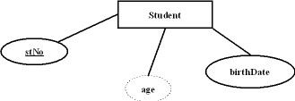

**6. Define relationship and give an example.**

A relationship is an association among several entities. For example, we can define a relationship n number of student as a member of m teams and a single student as a leader of a single team.



**7. Explain the difference between a relationship class and a relationship instance.**

**8. Define degree of relationship.**

The number of entity sets that participate in a relationship is called the degree of relationship.

The three most common degrees of a relationship in a database are:

1. unary (degree 1),
2. binary (degree 2), and
3. ternary (degree 3).

**9. List and give an example of the three types of binary relationships. Draw an E-R diagram**

**for each.**

10. Define the terms maximum cardinality and minimum cardinality.

11. Explain the distinctions among the terms primary key, candidate key and super key.

12. What are the main building modules of the entity relationship model? Discuss each one.

13. What is composite attributes, when it is used?

14. Explain the difference between single-value attributes and simple attributes.

15. Discuss the difference between a composite key and a composite attribute. How would

each indicated in an E-R diagram?

16. What two courses of action are available to a designer when a multivalued attribute is

encountered ?

17. Explain the various terms of an E-R model and how are they represented in an E-R

model?

18. Explain the concept of dependent entities? Give example.

19. What is the difference total and partial participation? Explain.

20. What do you mean by mapping cardinalities ? explain various type of cardinalities.

21. What is the difference between single-value and multivalued attributes? Explain

22. Explain the concept of participation constraints.

23. Difference the binary relationship with ternary relationship with example.

24. Explain the difference between weak and strong entity set.

25. Define the components of extended E-R features.

26. Define the concept of aggregation. Give two examples of where this concept is useful.

27. Explain the distinction between disjoint and overlapping constraints.

28. Explain the distinction between total and partial constraints.

29. Write short notes on:

· Specialization

· Generalization

· Aggregation